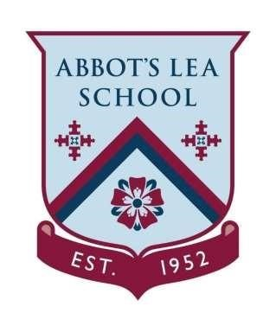
Abbot’s Lea school
Sports Premium Plan
2023 - 24

Throughout the academic year 2023-24, we are committed to enhancing the quality and variety of PE and sports activities available to our students. Our investment will prioritise fostering greater enthusiasm for sports and ensuring inclusivity, particularly for Looked After Children (LAC) and post-LAC students.

Our expenditure will centre on expanding access to a diverse range of sporting endeavors, with a special emphasis on therapeutic activities and adaptable learning environments. Our aim is to encourage active participation and holistic development among all pupils.

Outdoor Learning Opportunities | £1,600 | Students in the Primary department identified as Looked After Children (LAC) or previously Looked After (post-LAC) will receive dedicated support to join school residential activities. This initiative aims to enhance their engagement and broaden access to outdoor learning experiences.
Access to Sporting Competitions (James Dixon) | £300 | James Dixon sporting events including access to Boccia, Swimming Galas, Football tournaments, Basketball tournaments.
Climbing Wall Training | £1000 | Climbing Wall training for the staff to enable them to assist and instruct the students on the climbing wall.
Swimming | £6468 | Additional swimming instruction to promote water safety, confidence and competence across the school.
Access to PE through OT provision | £3632 | We will support our students to access the full breadth of Physical Education opportunities with the support from an Occupational Therapist (OT). Students wh struggle to physically access PE ill be observed and supported as part of our MDT offer.
Sporting and Sensory Equipment | £3200 | We will further enhance the equipment in school and will develop our PE and Sensory equipment identified (with Occupational Therapist) top support the students.
TOTAL FUNDING | £16,200

