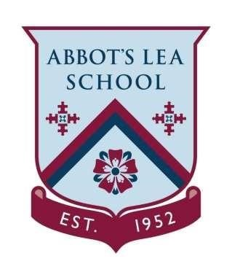
Abbot’s Lea school
Sports Premium Plan
2022 - 23

During the academic year 2022 – 23 focused support will be provided to improve the quality and breadth of the PE and sport activities we offer our pupils. Sadly, Covid-19 restrictions have hampered many planned activities during the past 18 months. Visits will be undertaken in a Covid-19 safe manner.

Greater engagement in sport and widening access to sport will be the key feature of our spending.

Access to a broader spectrum of sporting opportunities will continue to be a prominent theme with a focus on therapeutic activities and opportunities for pupils to learn in flexible environments.

Little Sunshine Yoga | £1,480 | We will continue to develop student’s emotional intelligence, well-being and mental state by focusing on the present moment, while  acknowledging and accepting one’s feelings and thoughts through movement as a therapeutic technique.
Access to Sporting Competitions (James Dixon) | £300 | James Dixon sporting events including access to Boccia, Swimming Galas, Football tournaments, Basketball tournaments.
Climbing Wall Training | £1000 | Climbing Wall training for the staff to enable them to assist and instruct the students on the climbing wall.
Judo | £1,800 | We will continue to provide students with a wider range of sports and encouraging them to engage in clubs in their community.
Swimming | £9240 | Additional swimming instruction to promote water safety, confidence and competence across the school.
Sporting and Sensory Equipment | £2380 | We will further enhance the equipment in school and will develop our PE and Sensory equipment identified (with Occupational Therapist) top support the students.
TOTAL FUNDING | £16,200

