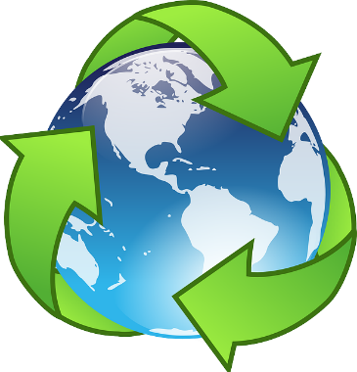Name: Date:

Teacher comments: Self-Assessment:

LO: To be able to recognise the impact humans have on the environment

The Planet needs your help! Can you think of two things you could change in your everyday life to help protect the planet?

Task: Draw and label two changes you could make to help protect our planet and consider what the environmental impact of making these changes would be.