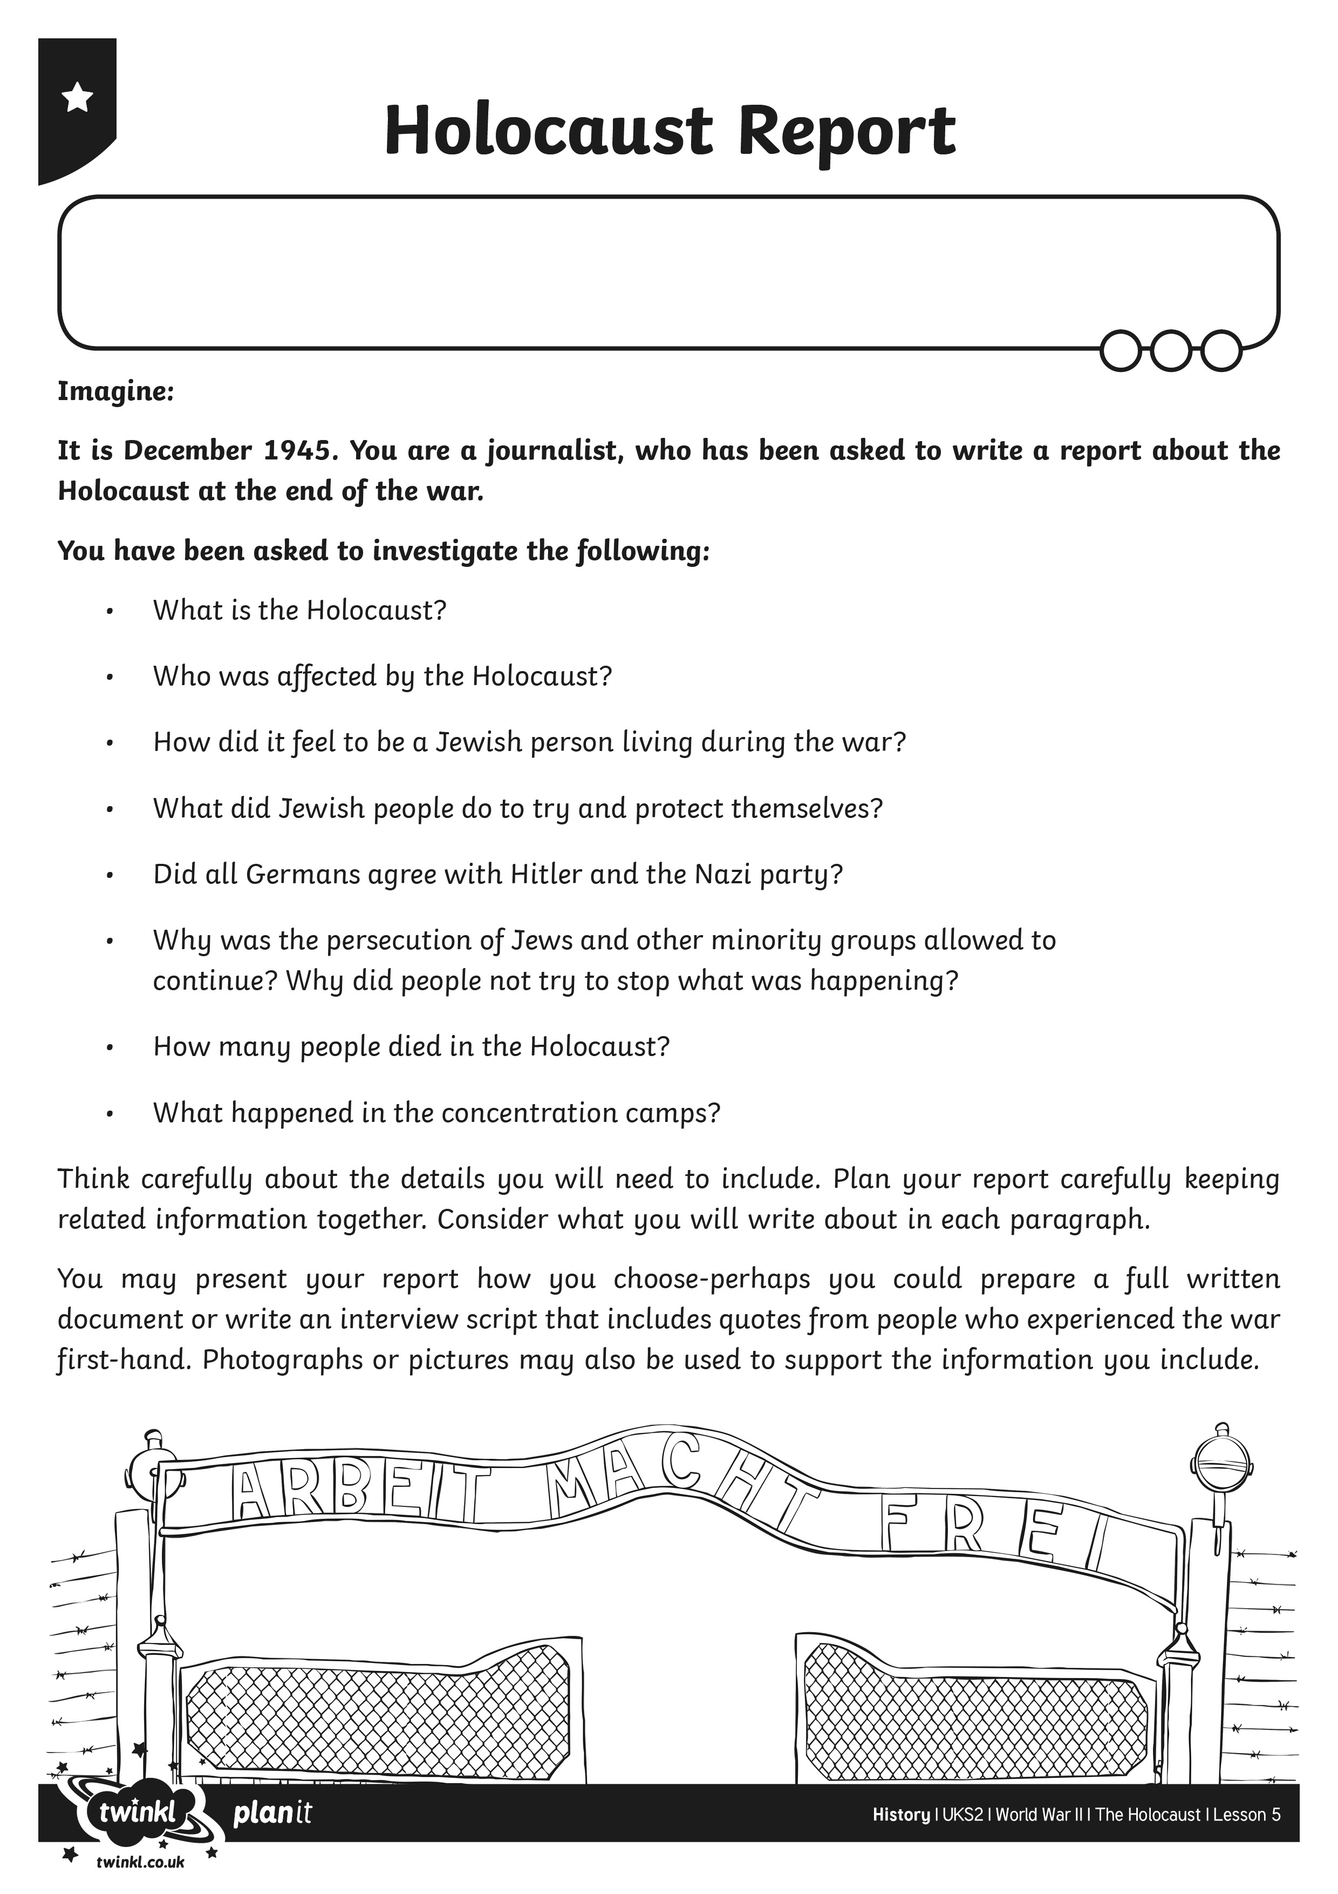
I can describe how and why Jews were subject to Nazi prejudice and discrimination during the war.
I can recall and report key facts about the events of the Holocaust.
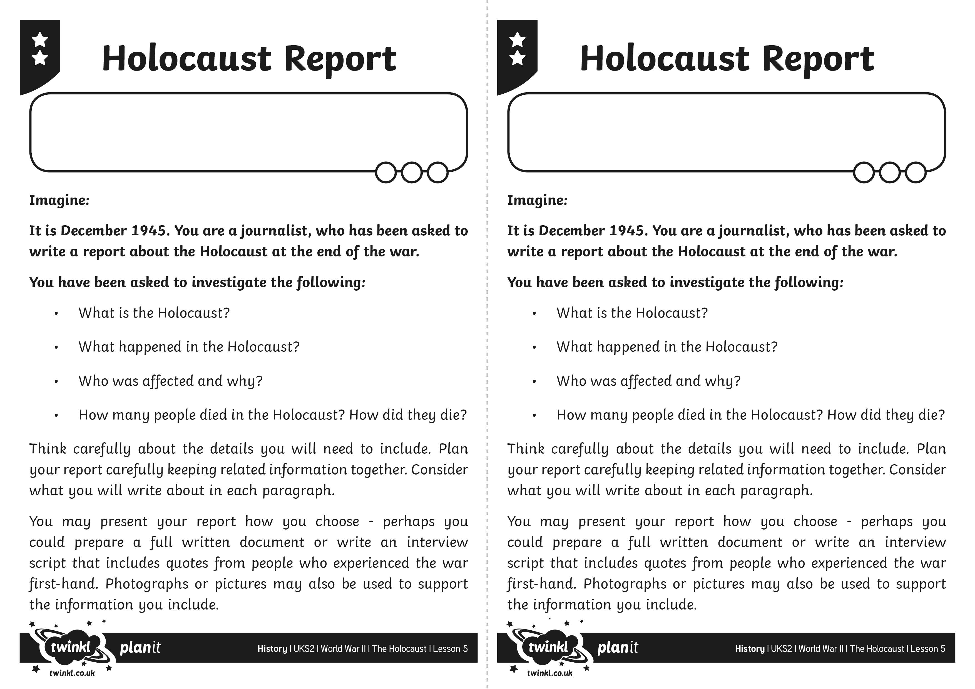
I can describe how and why Jews were subject to Nazi prejudice and discrimination during the war.
I can recall and report key facts about the events of the Holocaust.
I can describe how and why Jews were subject to Nazi prejudice and discrimination during the war.
I can recall and report key facts about the events of the Holocaust.
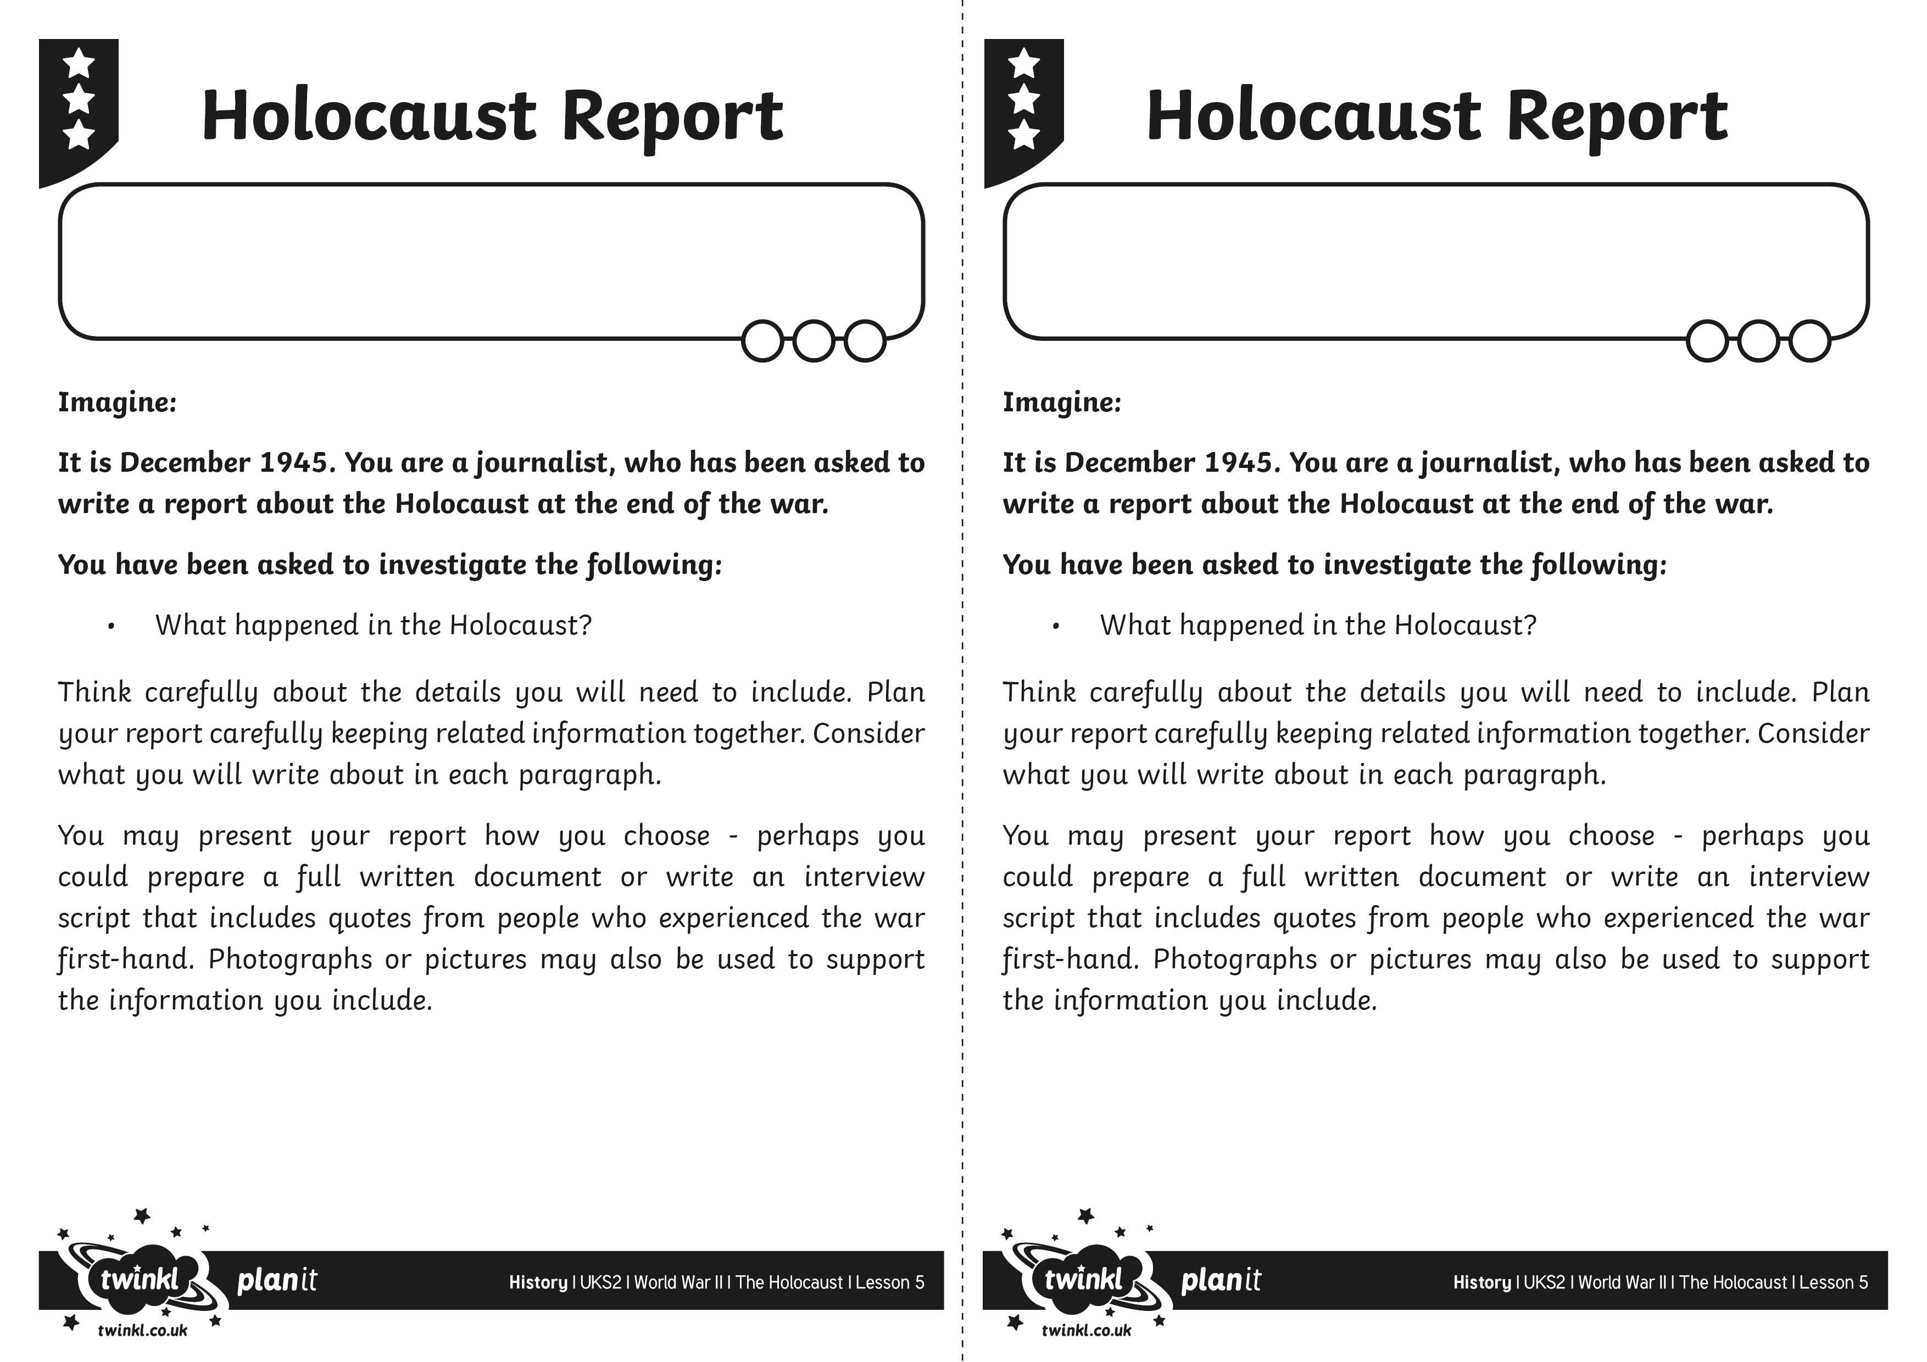
I can describe how and why Jews were subject to Nazi prejudice and discrimination during the war.
I can recall and report key facts about the events of the Holocaust.
I can describe how and why Jews were subject to Nazi prejudice and discrimination during the war.
I can recall and report key facts about the events of the Holocaust.

